Creating a Basic Linux VM in Azure

Problem Statement: Create a basic Linux virtual machine in Azure Description:You will create a Linux virtual machine.
Step 1:Go to portal.azure.com and sign into your Azure account. Your dashboard page of Azure Portal will appear on the screen as shown below:
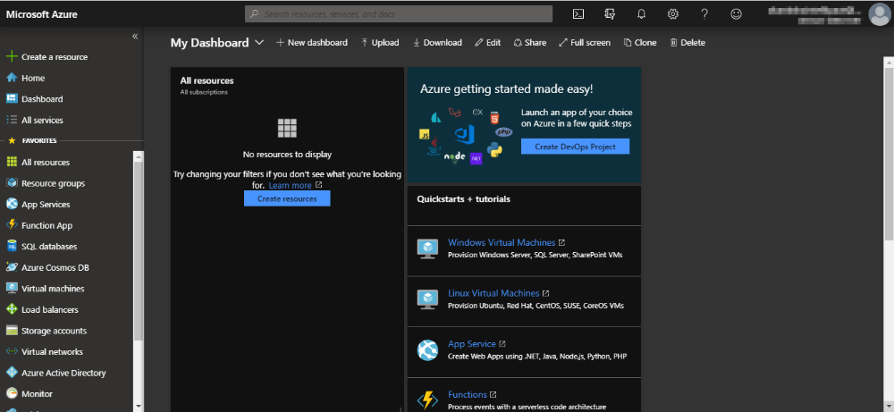

Step 2: Navigate to Resource groups on the left-side menu as shown in the following image:
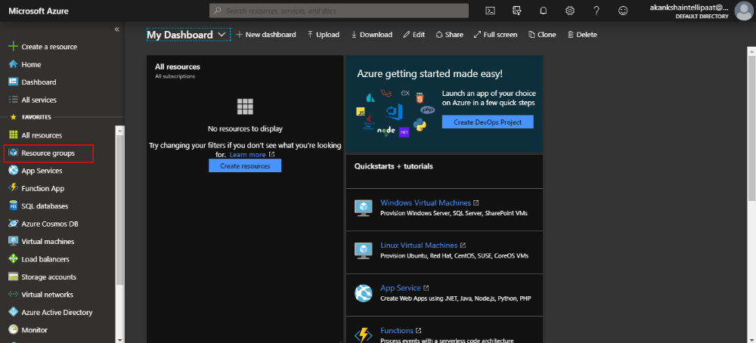
Step 3: When you click on theResource groups option, you will be taken to the Resource groups dashboard where you’ll see various options such as Add, Edit column,and more.Click on the Add option
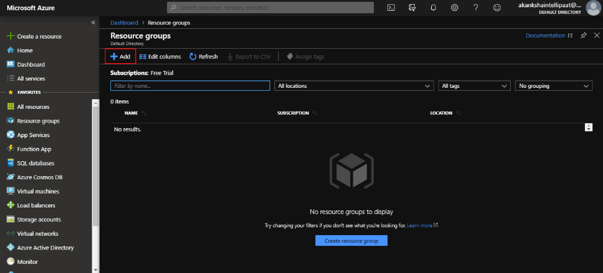
Step 4: Provide a name for your resource group in the respective field. You can keep the subscription as per your Azure subscription and then click on Review & create
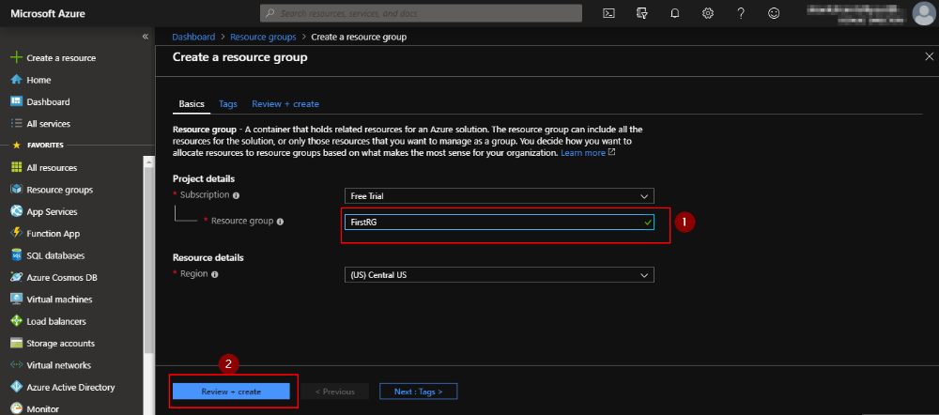
Step 5: You will be taken to the final page in creating a resource group. Check if the Validation passed message is displayed as shown in the following screenshot. If yes, then click on Create
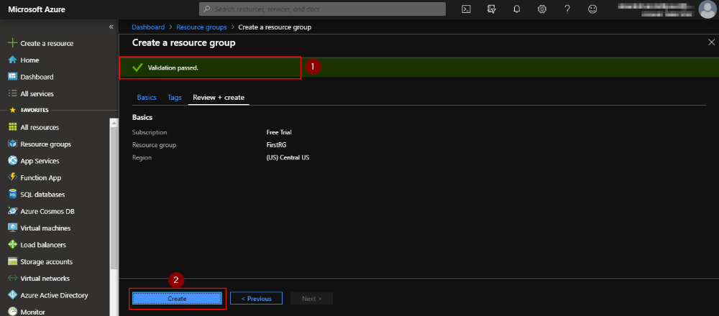
Step 6: You’ll get a notification saying that the resource group is created, and you will be able to see your resource group listed in your resource group dashboard
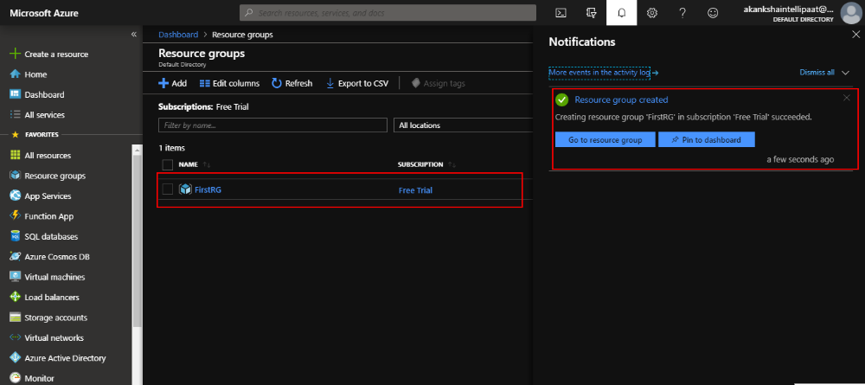
Step 7: Go back to the dashboard and select Virtual machinesfrom the left-side menu in Azure Portal
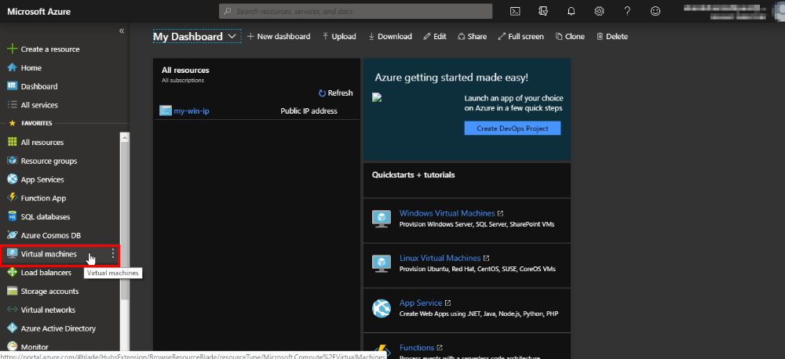
Step 8: When the following page appears, click on the Add option again
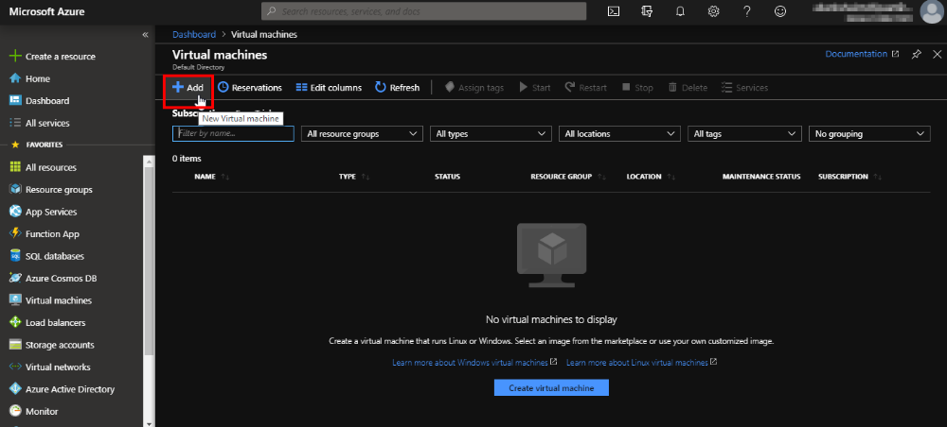
Step 9: Select the resource group that youjust created in the resource group field and then provide the name of the VM. You can keep the subscription as per your Azure subscription. In the image field, select the OS you want for your VM, and then choose the size as Standard DS1 v2.You can keep the region and availability options fields with default values as shown below: Note: The name for the resource should be unique.
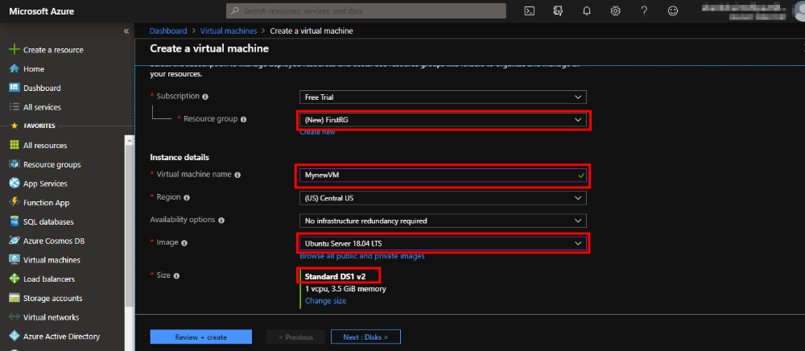
Step 10: Staying at the same page, scroll down. You’ll see some more fields to be filled in. Choose SSH public key in the Authentication type field, since you will be SSHing into the VM to connect with it. Provide any username that you want for your VM
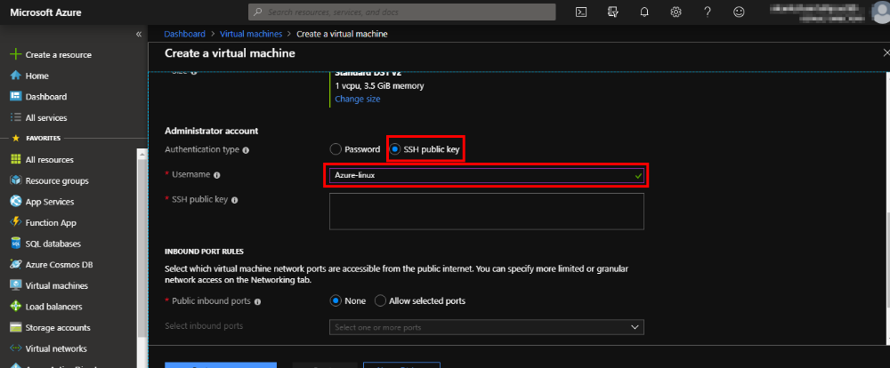
Step 11(a): Download and install PuTTY. Once done, open PuTTYKey Generator.It will look like the following screenshot:
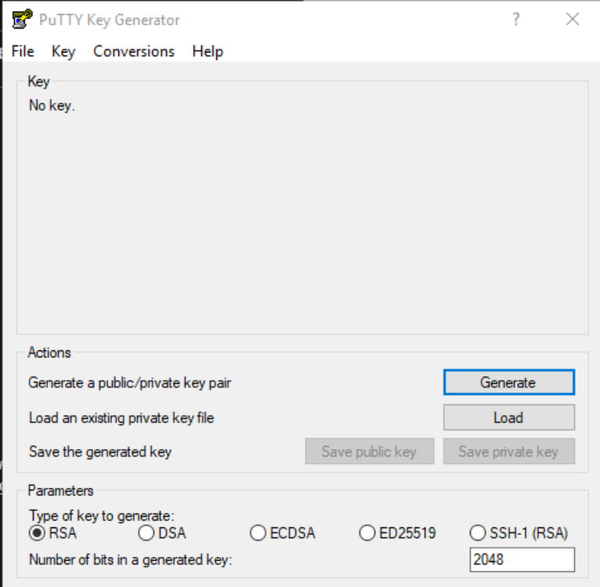
Step 11(b): Click on the Generate button in the above screen and a public key will be created for you as shown below:
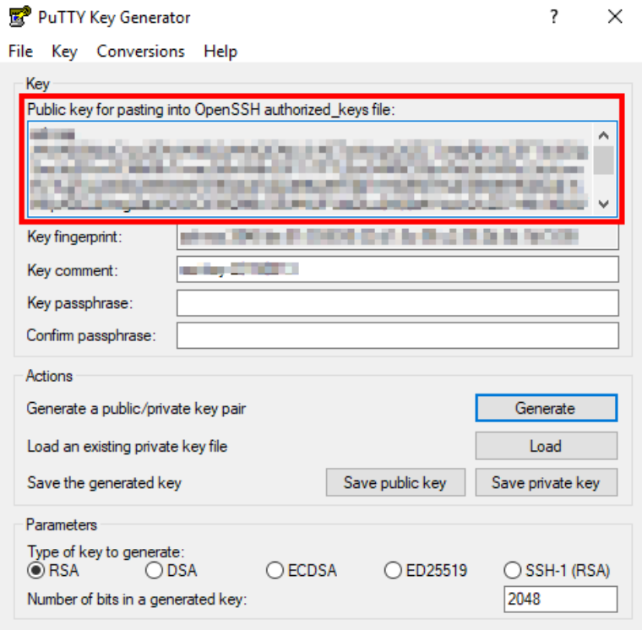
Step 12: Copy the public key and paste it in the SSH public key field in Azure Portal as shown below:
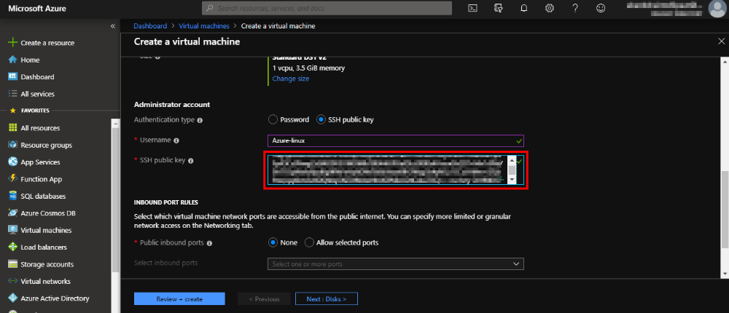
Step 13: In Public inbound ports, select Allow selected ports and then from the drop-down, select SSH. If you want to run a web server to create any application on your VM, then you also need to select HTTP
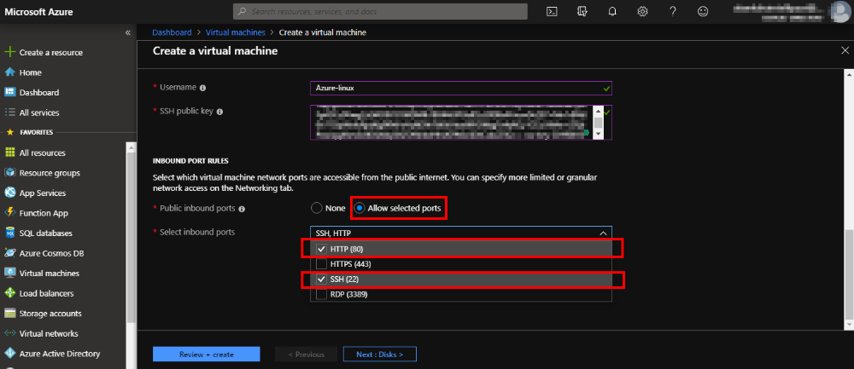
Step 14: Now, click on Review + create, first, and then, in next page, click on Create
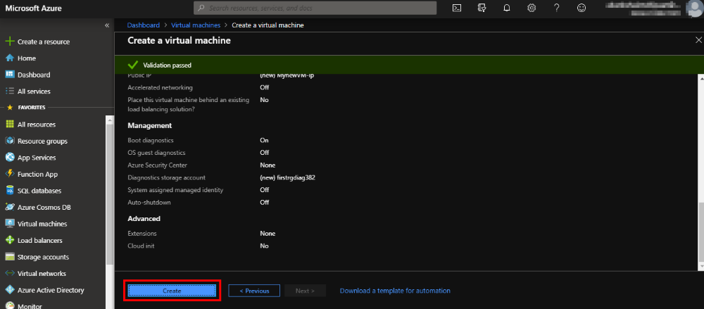
Step 15: Go back to the PuTTY keygen tool and click on Save private key
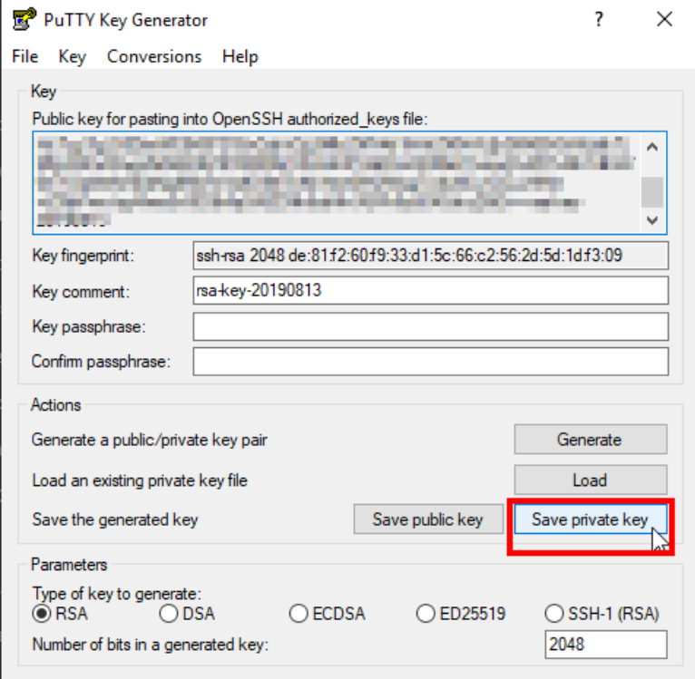
Step 16:Once done, you’ll get a message:‘Your deployment is complete’
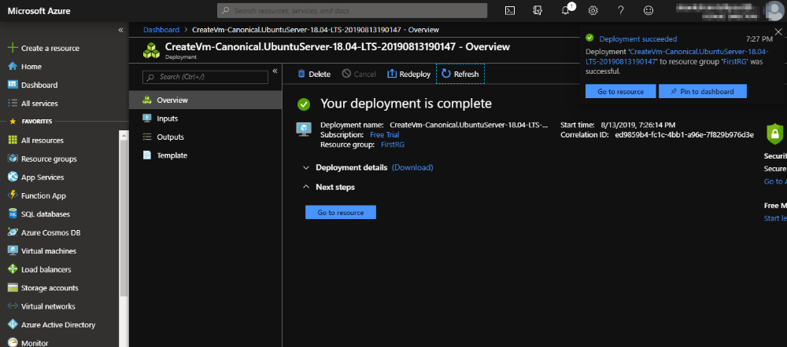
Step 17: Now, open the PuTTY tool. It should look like the following screenshot:
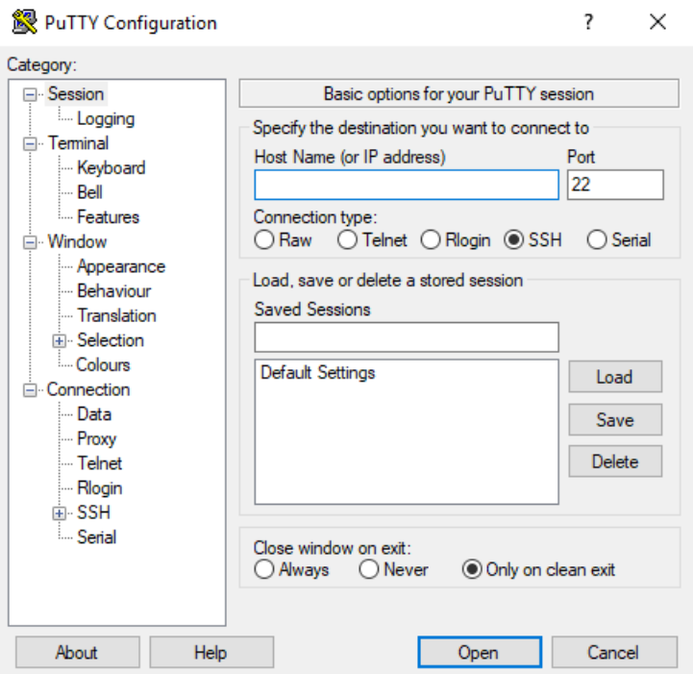
Step 18: Copy the public IP address of your VM
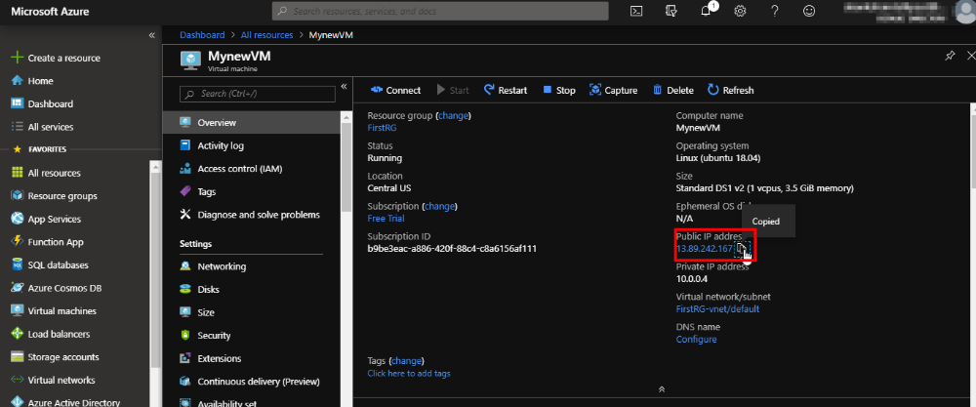
Step 19: Paste the IP address in the Host Name field in the PuTTY tool and then click on the plus symbol of the SSH option in the right menu bar
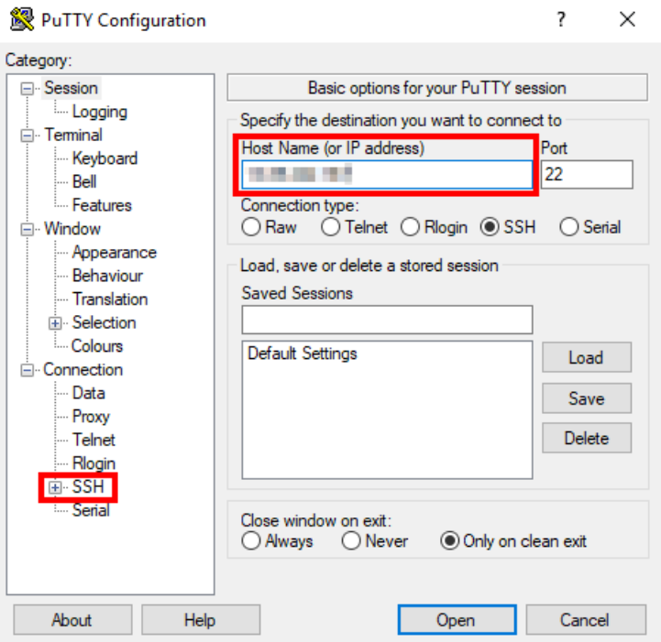
Step 20: Fromthe sub menu of SSH, select Auth. Then, browse and select the private key you saved in Step 15, and then click on Open
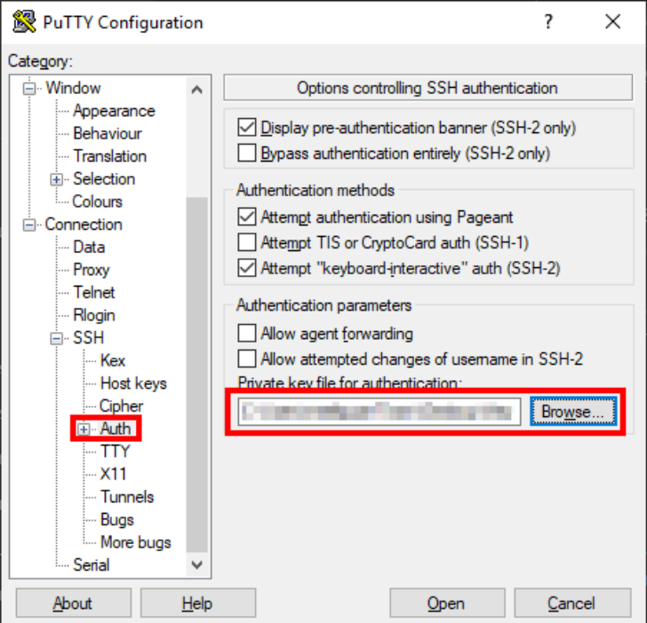
Step 21: In the PuTTY security alter pop-up box, click on Yes and then provide the username that you set in Step 10
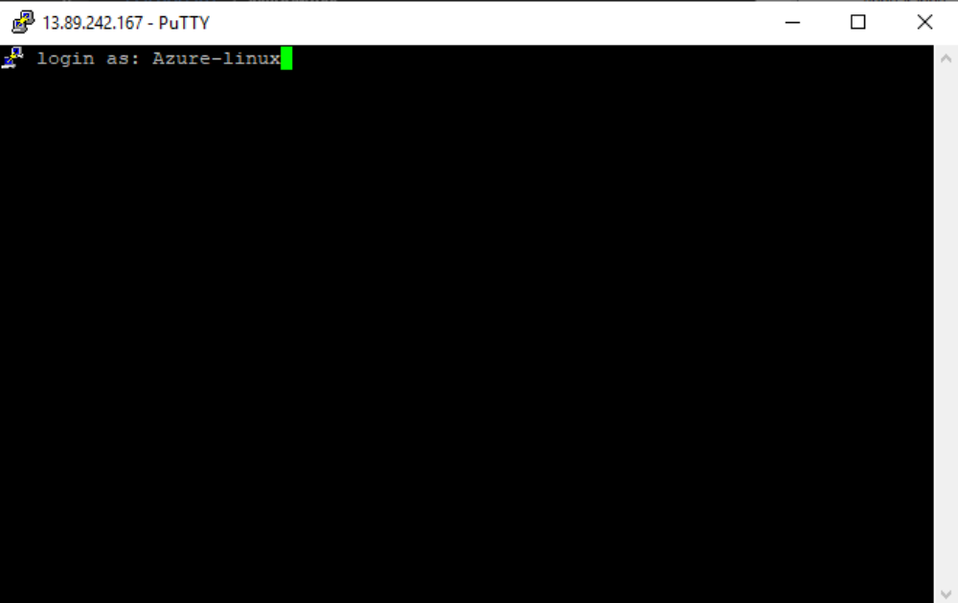
Step 22: Once the connection is successful, it should look like the following screenshot:
